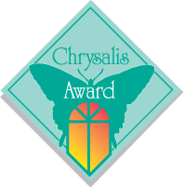
August 13, 2020

Dear Sonny,

Congratulations again to Michael Nash Design Build & Homes, Inc. for winning two more Chrysalis Awards In 2020, adding to an already impressive collection.

Michael Nash is one of only seven companies to be recognized with the Decade of Excellence Award for winning a Chrysalis Award in ten separate years. You are also the only remodeling company in the eastern United States to be so honored.

In the twelve years you have submitted entries you have won at least one award every year including 22 Regional Chrysalis Awards covering 12 states from Florida to Virginia and west to Texas. You have also won 10 National Awards where your projects were judged the best in the nation, the highest number of National Awards of any company that has participated in Chrysalis in the U.S. It’s noteworthy that these awards are in the most competitive categories such as Kitchen, Bath, Additions, Interior and Exterior Remodeling, Detached Outbuilding and in the Whole House Remodel.

While this variety of winning projects demonstrates the breadth of the company, the fact that you have won a Chrysalis Award for twelve consecutive years, reflects your long-term commitment to the highest level of design excellence and professionalism.

I am proud to be able to list your accomplishments to the industry and the public and look forward to your continued success.

Ken Kanline
Chrysalis Awards for Remodeling Excellence

